Yesenia Burgos
Baddie Budget
Capstone Spring 26’
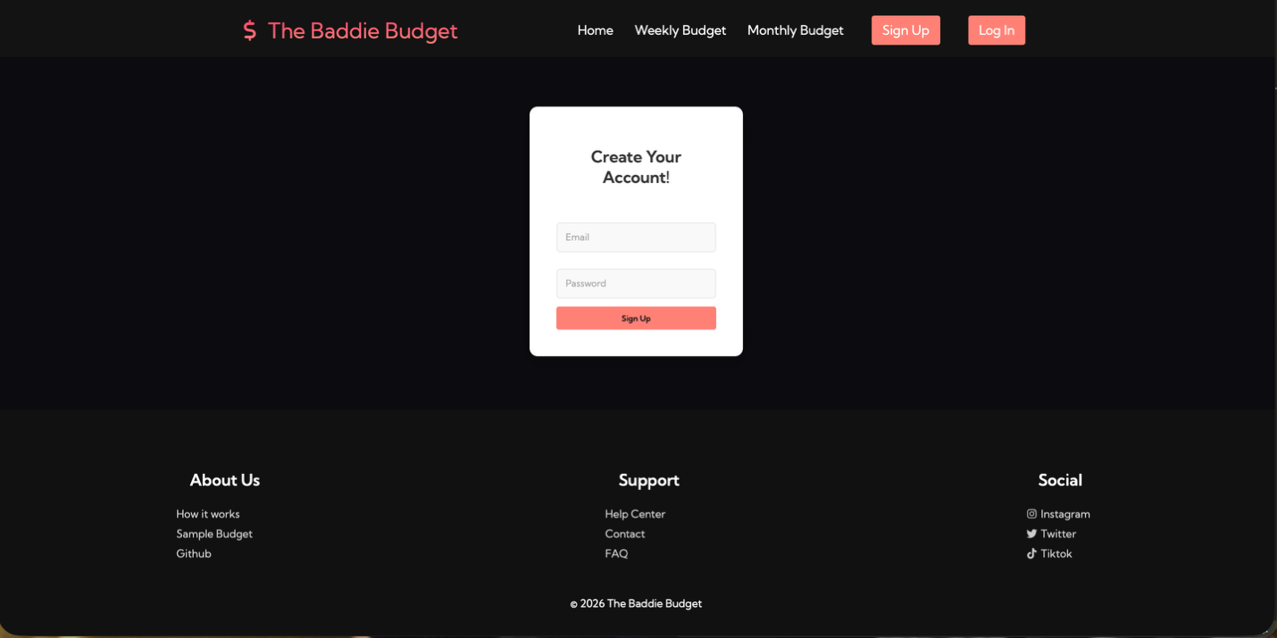

signUp.html
Upon clicking sign up, the user is prompted to create an account using an email and password of their choice. Passwords must be 6 characters minimum. If the password requirements aren’t met, an error message display. Upon successfully, signing up the user is automatically directed to dashboard.html.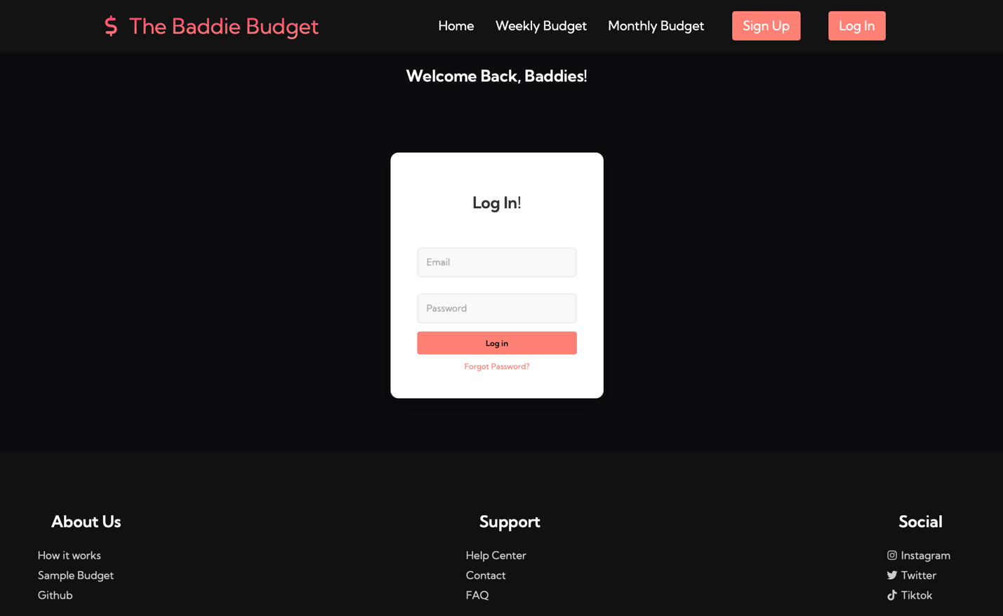
login.html

After pressing log in, the user is prompted to enter their email and password to log in. If logged in successfully, user is automatically directed to dashboard.html. There’s also an option for forgot password if the user cannot log in successfully with their credentials.

